Chapter-3

ENTERPRISE MANAGEMENT SYSTEMS

- ENTERPRISE MANAGEMENT SYSTEMS

  - It is enterprise wide information system designed to coordinate all the resources, information and activities needed to complete business processes.

  - The focus of ERP is on resource management within constraints to return on investment

  - The ERP package design is built on the principle of ‘Best Practices’

- ENTERPRISE SOFTWARE: ERP/SCM/CRM

• Enterprise software, also known as enterprise application software (EAS) is purposed – designed computer software used in the furtherance of the needs and objectives of the organizations.

• Purpose to use the EAS can vary widely in business ,schools, interest-based user groups and clubs ,retailers or government

- Enterprise software_{Ghimire,Dept}isanintegralpart of computer based information system.

- Services provided by enterprise software are typically business oriented tools such as online shopping and online payment processing, interactive product catalogue ,automated billing systems security, Enterprise Content Management, IT Service management, Customer Relationship Management , Enterprise Resource Planning , Business Intelligence ,Project Management ,Collaboration, Human Resource Management,

Manufacturing ,Enterprise Application Integration ,and Enterprise Forms Automation

- Enterprise Software describes a collection of computer programs with common business applications, tools for modeling how the entire organization works, and development tools for building unique to the organization.

- Enterprise applications are about the display ,manipulation, and storage of large amount of often complex data and the support or automation of business processes with the data

1 Compiled By:-Shraddha Bikash Upadhyay ,Asst.Prof,NEC
Chapter-3

- Enterprise application software performs business functions such as order processing, procurement, production scheduling, customer information management, energy management, and accounting. It is typically hosted on servers and provides simultaneous services to a large numbers of users, typically over a computer network

TYPES OF ENTERPRISE SOFTWARE

- Enterprise software can be categorized by their business function

- Different types of Industry Standard Enterprise Software product categories have emerged, and these are shown below:

- Accounting Software

- Business Intelligence

- Business Process Management

- Content Management Systems(CMS)

- Customer Relationship Management(CRM)

- Database

- Master Data Management (MDM)

- Enterprise Resource Planning(ERP)

- Enterprise Asset Management (EAM)

1) Enterprise Resource Planning (ERP)

Enterprise resource planning (ERP) is business-management software—typically a suite of integrated applications—that an organization can use to collect, store, manage and interpret data from many business activities, including: product planning, cost. Manufacturing or service delivery. Marketing and sales. Inventory management shipping and payment

Function Areas of ERP

Financial Accounting, Management Accounting, Human Resources, Manufacturing, Supply Chain Management, Project Management, Customer Relationship management etc.

2
Chapter-3
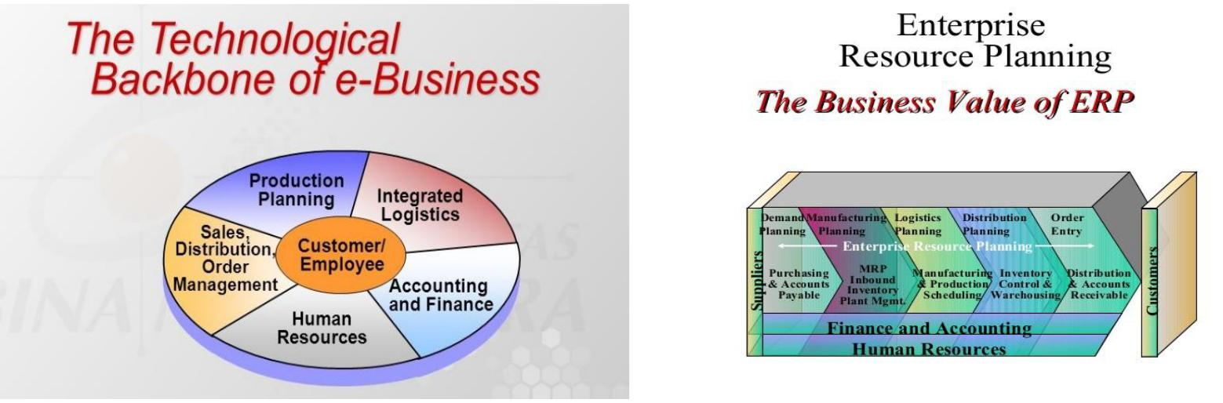

Fig 3.1Technical Backbone of e-Business Fig 3.2 The business Values of ERP

Benefits of ERP

  - Quality and Efficiency

  - Decreased Costs

  - Decision Support

  - Enterprise Agility (power to move freely)

  - Data Security

  - Increased opportunities for collaboration Drawbacks of ERP

  - Underestimating the complexity of planning, development, and Training needed.

  - Failure to involve affected employees

  - Trying to do too much too fast

  - Over Reliance by company on claims of software companies

- Customer Relationship Management

Customer relationship management (CRM) is an approach to managing a company’s interaction with current and future customers. The CRM approach tries to analyze data about customers' history with a company, in order to better improve business relationships with customers, specifically focusing on retaining customers, in order to drive sales growth.

3
Chapter-3

One important aspect of the CRM approach is the systems of CRM that compile information from a range of different channels, including a company’s website, telephone, email, live chat, marketing materials, social media, and more. Through the CRM approach and the systems used to facilitate CRM, businesses learn more about their target audiences and how to best cater to their needs. However, the adoption of the CRM approach may also occasionally lead to favoritism within an audience of consumers, leading to dissatisfaction among customers and defeating the purpose of CRM.

i.e. CMR support integrated and collaborative relationship between a business and its customer
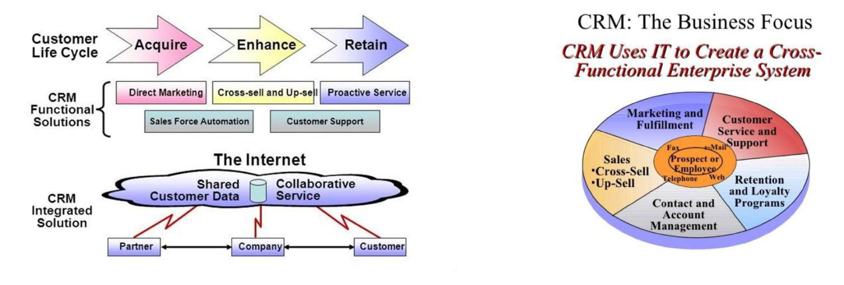

Fig 3.3 CRM-The Busin ss Focus Fig 3.4 CRM Uses IT

Benefits and Challenges of CRM

- Identify and target the best customers

- Customization and Personalization of Products and services

- Track Customers Contacts

CRM Failures

- 50 % of Applications Fail to meet Expectations

- 20% of the Time CRM Damaged Customer Relationships

- Lack of understanding and preparation is blamed.

4
Chapter-3

Gevity HR and Monster.com: Failures in CRM implementation

- Employees undercut the system believing their jobs threatened by CRM On-Line customer Problem Solutions.

- Complex Installation Since it touches So many legacy systems

- Failures lead to loss of customers Goodwill and Business and Negatively Affects Employees Also.

TELSTRA CORPORATION: THE BUSINESS VALUE OF CRM

  - Provides Fixed ,wireless and e-commerce Services to Customer Base in 19 countries

  - Offers Voice , Data ,Internet , Multimedia and communications services

  - Sought CRM solution to integrate More than 20 core Legacy Databases across the system

  - Benefits Quickly followed

  - Reduced Training time

- Supply Chain Management

Supply chain management (SCM) is the management of the flow of goods and services.^{[2]} It includes the movement and storage of raw materials, work-in-process inventory, and finished goods from point of origin to point of consumption. Interconnected or interlinked networks, channels and node businesses are involved in the provision of products and services required by end customers in a supply chain.

5
Chapter-3

Supply chain management has been defined as the "design, planning, execution, control, and monitoring of supply chain activities with the objective of creating net value, building a competitive infrastructure, leveraging worldwide logistics, synchronizing supply with demand and measuring performance globally.
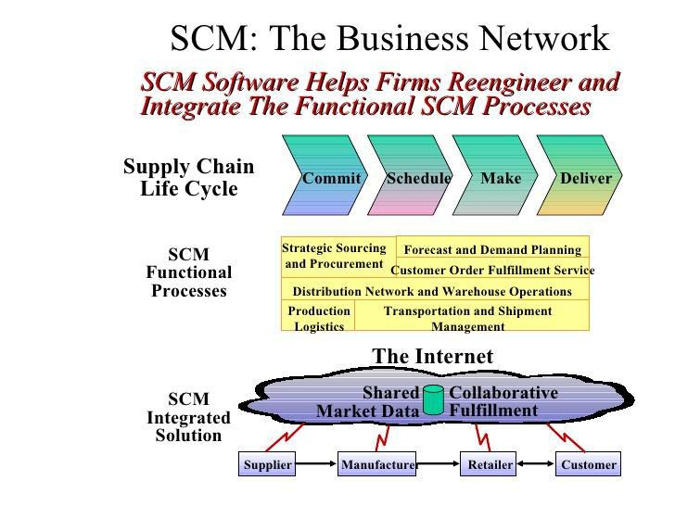

Fig 3.5 SCM: The Business Network

Supply Chain Management: A Top Strategic objective for many firms

- The right products

- The right place

- The right time

- In the proper quantity

- At an acceptable cost

6
Chapter-3
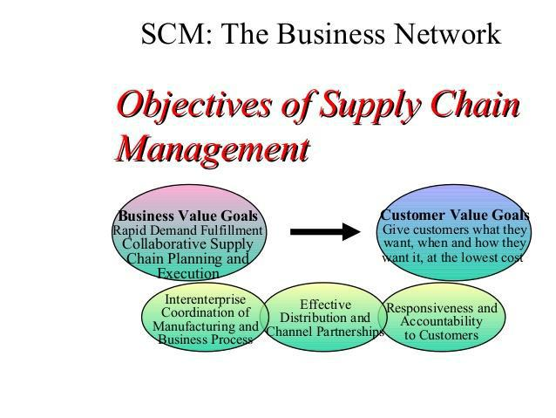

Fig 3.6: Objectives of supply chain Management

Objectives of SCM Efficiently manages this process by:

- Forecasting Demand

- Controlling Inventory

- Enhancing Business Relationship

- Receiving Feedback and status of every link of the chain

Benefits and challenges of SCM

- Lack of proper planning knowledge, Tools and Guidelines

- Inaccurate Demand Forecasts

- Lack of Adequate Collaboration

- Software Itself Immature

7
Chapter-3

3.3 Information Management and Technology of Enterprise Software

Enterprise Information Management

- Enterprise Information Management (EIM) is a particular field of Interest within Information technology area that specializes in finding solutions for optimal support information within an organization.

- EIM is the effort and practice of reaching across all data and application storages embedded in the organization’s operating infrastructure and binding those repositories together into one effective information management environment

- EIM combines Business Intelligence (BI) and Enterprise Conte t Management (ECM) to overcome traditional IT-related barriers to manage information on the enterprise level .

- First and foremost, EIM exists to support business obj ctives.

- EIM is solely about managing information assets across the entire enterprise

- EIM involves fostering, creating, and maintaining practice that allow the business to optimize data access and usage regardless of where the data resides and what functional entity needs it

- Agility, accuracy and completeness of data delivery are three primary objectives

- EIM spans the entire corporation, regardless of size, from a small,30 –person garment marker to a 50,000-persons ,multinational manufacturer.

- EIM Steps

1. Orga ize

- Establish ownership

- Executive Sponsor

- Steering committee

- Roles and Responsibilities

- Governance level

8
Chapter-3

- Implementation level

- Administration level

- Determine Program Scope 2. Evaluate
- Conduct a thorough records inventory

- Evaluate your existing program, its strengths, limitations and capabilities

- Determine the potential areas of risk and/or exposure to compliance regulations

- Analyze your legal retention and access requirements

- Build an overall master plan based on your assessments and all applicable compliance regulations

Enterprise Management

WHAT IS INFORMATION SYSTEM?

IS(Information System) is the collection of technical and human resources that provide the storage ,computation ,distribution ,and communication for the information required by all or some part of an enterprise.

ROLES IS IN ENTERPRISE MANAGEMENT

1) Automation of Manual Tasks

- Resulting in saving time, money and resources

- Enhances organizational workflow

- Various Types of IS ranging from Robotics IS to Logistic IS Automates manual tasks

2) Hardware and Software Integration

- Merge Hardware and software systems as a scalable platform.

- An open Architecture IS allows for integration at all the levels throughout an organization.

9
Chapter-3

- E.g: Local Area Network (LAN) can integrate into a mainframe system that processes accounting information through a concept called a “gateway”

  - Support a Multi-Processing Environment

Support a real-time multi-processing environment through the concept of time sharing application

Access to various departments, divisions or branches of the system at the same time intervals

- Provides Data for System Support

Compilation of Data into Information for analysis of several areas and create scenarios through the information system for a desired result.

Results in improving productivity

WHAT IS INFORMATION TECHNOLOGY?

IT(Information Technology) is a term that encompasses all forms of technology used to create ,store, exchange and use information in its various forms(business data, voice conversations ,still images ,motion pictures ,multimedia presentations ,and other forms, including those not yet conceived)

1) Communication

Allows staff to communicate using emails (previous used), live chat systems, online meeting tools and video-conferencing systems.

Voice over internet protocol (VOIP) telephones and smart-phones offer even more high-tech ways for employees to communicate

2) Inventory Management

Tracks the quantity of each item a company maintains, triggering an order of additional stock when the quantities fall below a pre-determined

3) Data Management

10
Chapter-3

Storage and maintenance a tremendous amount of historical data economically, and employees benefits from immediate access to the documents they need.

4) Management Information Systems

Enables companies to track sales data, expenses and productivity levels

Can be used to track profitability over time, maximize return on investment and identity area of improvement

5) Customer Relationship Management

Captures every interaction a company has with a customer, so that a more enriching experience is possible.

Analysis Resulting Better Productivity.

- ENTERPRISE ENGINEERING

  - It is defined as the body of knowledge, principles, and practices to design an enterprise. An enterprise is a complex, socio-technical system that comprises interdependent resourc s of people, information, and technology that must interact with each other and their environment in support of a common mission.

  - Enterprise eng neering is a sub discipline of systems engineering. The discipline examines each aspect of the enterprise, including business processes, information flows, and organizational structure.

  - Enterprise engineering may focus on the design of the enterprise as a whole, or on the design and integration of certain business components.

Three world view assumptions reflect the depth of Enterprise Engineering:

- The enterprise can be viewed as a complex system.

- The enterprise is to be viewed as a system of processes that can be engineered both individually and holistically.

- The use of engineering rigor in transforming the enterprise.

11
Chapter-3

Goals of Enterprise Engineering

  - Identify and integrate the most valuable and successful ways to change an enterprise

- To take them into a professional discipline with a teachable methodology and measures of effectiveness.

Seven Components of Enterprise Engineering

  - TQM ,Kaizen

  - Procedure Redesign

  - Value Stream Reinvention

  - Enterprise Redesign

  - Strategic Visioning

  - Human and Culture Development

  - Information Technology Development

TQM, KAIZEN

• | Ghimire,Dept
• | Continuous change applied across an enterprise
• Kaizen-Japanese Term For Continuous Improvement
Procedure Redesign
• | Discontinuous nvention of existing processes

Value Stream Reinvention

- Discontinuous reinvention of “end to end” streams

- Breakthrough improvement for the CUSTOMER.

Enterprise Redesign

- Discontinuous redesign

- Holistic change to a new world architecture, sometimes accomplished by building new business units of subsidiaries

Strategic Visioning

12
Chapter-3

- Process ,People and Technology

ELECTRONIC ORGANISMS

- As systems become more complex, the design of this systems must be automated.

- Electronic organisms, in fact all organism, Have to be complex, because they have to contain all the creative infrastructure necessary for their creation,reproduction, maintenance and action.

- But they can easily afford to be complex, because there is no need for detailed communication with a programmer.

- Electronic organisms have the ability to react immediately to unforeseen challenges without the need for a programmer to recognize the situation and deal with it by modifying a program

- Electronic Organisms do so by recurrence to fundamental goals and organizing principles, just as programmer do so now

- Electronic Organisms will live, grow and evolve in the rapidly growing world of installed computers and networks, just as microbes, plants and animals live in natural ecosystems

- Strong forces are pushing technology towards electronic organisms.

LOOSE VS Full Integration

- Loose

- Simple exchange of info

- No guarantee of same interpretation

- Ex. Dedicated interface

- Full

- Specificities are known only the one system

- Two systems contribute to a common task

- Two Systems share the definition of items exchanged

13
Chapter-3

PROCESS ALIGNMENT

- Business Aligned with IT

- Early definitions call for IT strategy (Henderson & Venkatraman,1989 & 1993)

- More recently, definitions call for IT in general ;no IT Strategy expected (Luftman et al 1999)

- Lately ,goals were introduced

- “Business and IT working together to reach a common goal”

(Campbell, 2005)

- Business goals and IT goals (Abraham ,2006)(Singh & Woo ,2009)
- …..”the linkage between the goals of the business and the goals of IT”

- (Abraham,2006)

- NO IT Strategy formulation required

- Goals focus on the whys and the h ws

- Integration of business and IT

- Business strategy and IT s rategy

• Fit between business n ds and IT priorities

- Long time commitment and planning with impact on IT planning

- Focused use of IT: improved performance

- “Commun cation of strategy is linked to successful implementation”

14
Chapter-3

INTEGRATED CHANGE FRAMEWORK
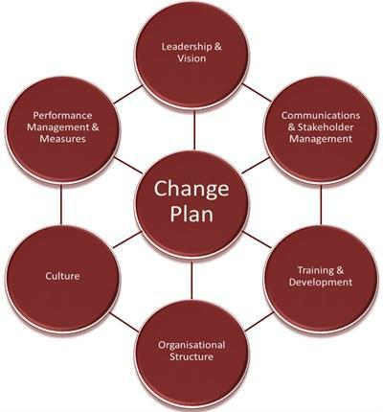

The Integrated Change Framework fuses experience of what works in the real world, alongside best practice business methodologies with the creative arts. This approach creates big-picture understanding that injects innovation and simplicity into the business problem, leading to the effective linking of overarching strat gy to daily operations

For change management to succ d, there are 7 elements it is essential to address:

- Leadership and Vision;

- Communication & Stake older Management;

- Training & Development;

- Organizational Structure;

- Culture;

- Performance Management & Measures; and

- Change Plan

FUTURE TRENDS

Trends 1: Cloud deployment models that change application economics

Trends 2: Mobile technology accelerated business processes

15
Chapter-3

Trends 3: Business process flexibility evolution via embedded modelling tools Trends 4: Application user experiences advancement

Trends 5: Extensibility improvement via platform-as-a-service

Trends 6: Elastic computing platforms scaled transactions and analytics Trends 7: Collaboration comes to applications in context via social tools

16

